VFC Uer Manual

A utility for X-Plane terrain editing

Colin Sare-Soar 2020

[1]

1. About Vector File Creator.

This project really started life back in 1998 or so when I was quite involved with the Terminal Reality Fly! Series of simulators. The terrain was not so detailed but still worked on the same principles as X-Plane does now and therefore a lot of code and ideas were already there and just required modernising. I apologize for the size of the required libraries but that is a consequence of using RAD Studio / C++ Builder.

The basic idea is to be able to extract the DEM data from whatever source and transform it so that it can be displayed and edited in a GIS or programatically. I use QGis for almost all my operations although I do have an old copy of Global Mapper as well as ESRI’s Arc Explorer(free). 20 years ago, it wasn’t easy to edit the DEMs without very expensive software but now Qgis will do it with the Serval plugin.

This is very time consuming, editing pixel by pixel and prone to errors and so I have automated the process to some extent as well as generating graphical vector files to help.

# Installation and use.

VFC does not use the registry, nor any system files. It does not write anything in the X-Plane folder tree although you have to retrieve the appropriate .dsf file to use and maybe an apt.dat file.

You can leave the executable and the Borland library files all in one folder.

VFC will create 2 folders labelled Input and Output in the installation folder and all write operations will be confined to these folders.

You will need to find a source of SRTM data (3 arcsec) which is freely available. I get mine direct from NASA where I opened a free account. It is also necessary to have Google Earth Pro installed so that you can see what you are doing. I don’t actually take any data from Google Earth but use it extensively for reference. A separate GIS is required to see what you are doing. QGis is free and open source and fairly easy to use for what we need. It is, of course, a very complex program but we only use a fraction of it’s capabilities. Google Earth is also a GIS but editing is limited.

1. Usage

The following steps really depend if you are editing an existing airport to make it usable/more realistic or creating a new one. This utility and methods are not really meant for use at large existing airports as they have most likely already had the terrain edited/flattened and in any case, large airports are generally built onwide open, reasonably flat spaces.

VFC is more useful when creating small airfields in less accessible places. Most of my testing has been done in PNG with it’s mountainous terrain and small airstrips that are largely unmapped in X-Plane. I will use Mok (AYMK) in New Britain Island for this manual.

This airfield does not exist in X-Plane but you can find it in Bing or Google Earth.

The Google Earth image is a bit blurred so I copied the Bing image onto it for clarity after geo-referencing withQGis.

Coordinates are -5.73° Lat 149.05° Long.

Here are some images before doing anything.

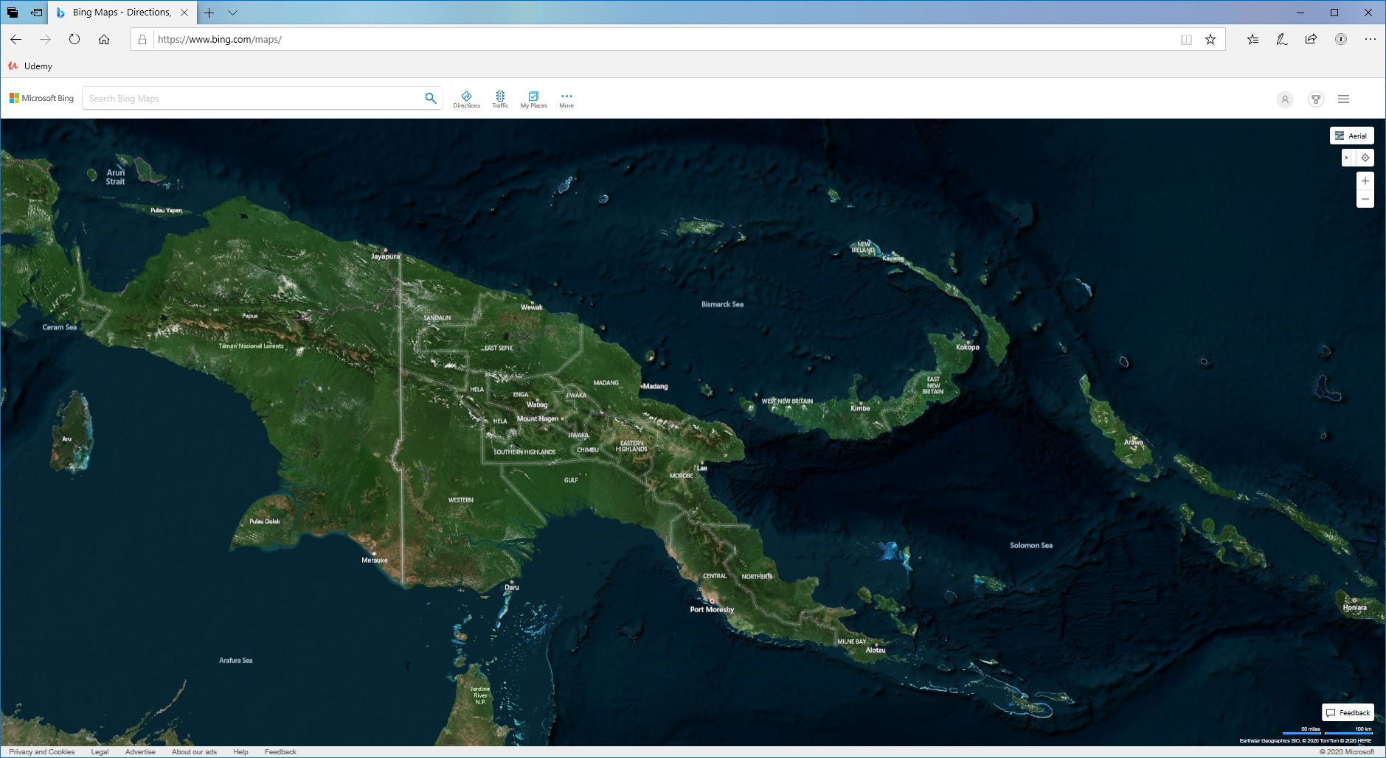

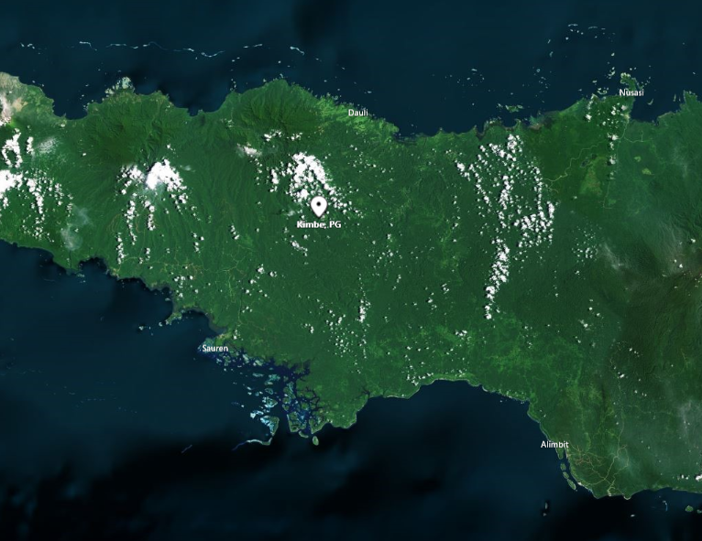

(Shown here in Bing as Kimbe)

Zoomed in:

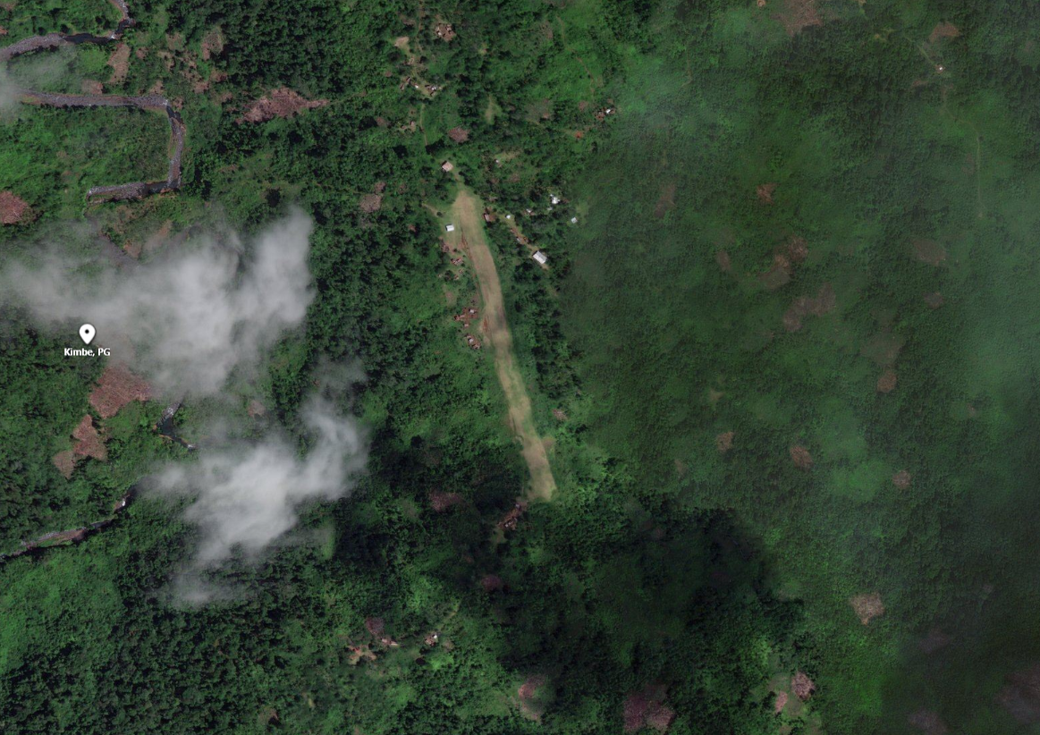

Mok air strip

Here it is patched onto Google Earth because there is more information available there. The saved image was geo-referenced using QGis and then simply loaded into GE.

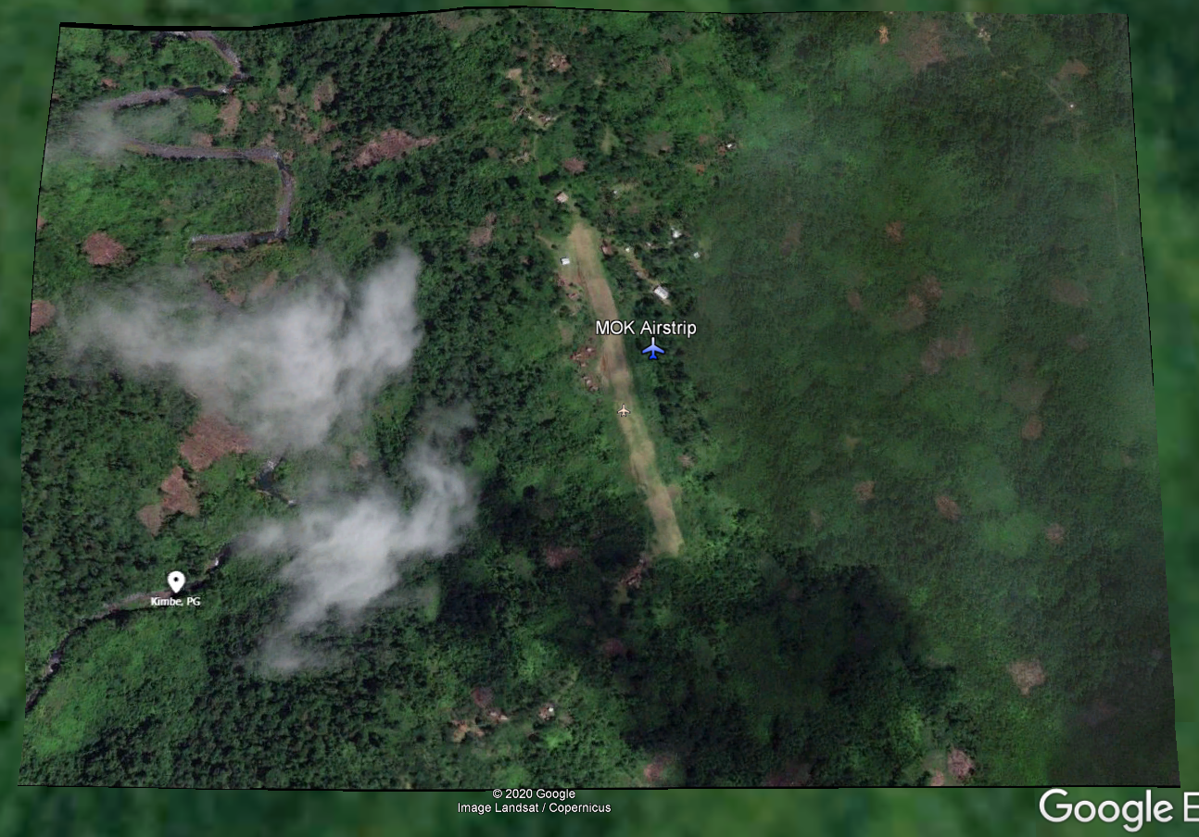

To begin, I simply get the runway end coordinates and width from this image to use in WED.

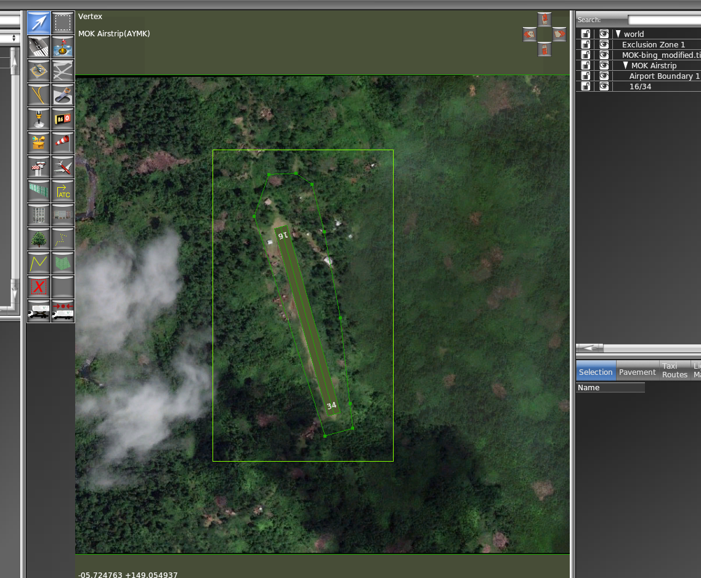

Here is the runway and a tif overlay in WED. From here you can create an exclusion area if required and export the apt.dat file and put it in your new scenery folder. This step was necessary in this case as the area is heavily forested and simply creating the runway leaves it covered in trees!

I then go to the area in X-Plane to ‘see’ how the runway looks. As this is a hilly, forested area the runway had some ups and downs and was not usable. It was possible (just) to taxi the length of the runway and see the elevations . This step is important because you can assess what needs changing terrain wise. At this point, scenery and other eye-candy is irrelevant, we are just interested in the terrain.

At this point, I like to generate the runway vector file using VFC.

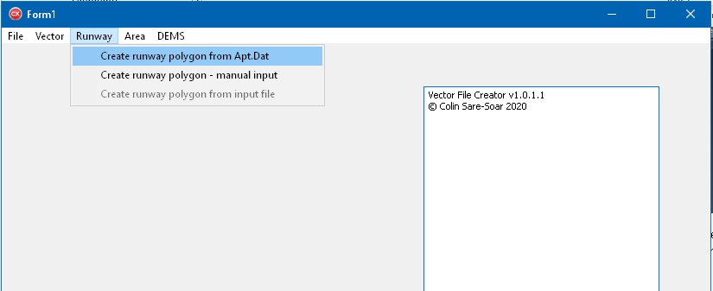

You can also generate the same file using the manual input option and the coordinates you already obtained but if you want to create the airport you will need the apt.dat file.

This will make a shapefile set, consisting of 4 files named according to your airport name.

For those not familiar with shapefiles, there will be the main vector file xxx.shp, an index file xxx.shx, a database file xxx.dbf and a projection file xxx.prj These can be viewed in QGis and Google Earth etc. You just have to load the xxx.shp file and ignore the others, QGis / GE will read them as required

QGis

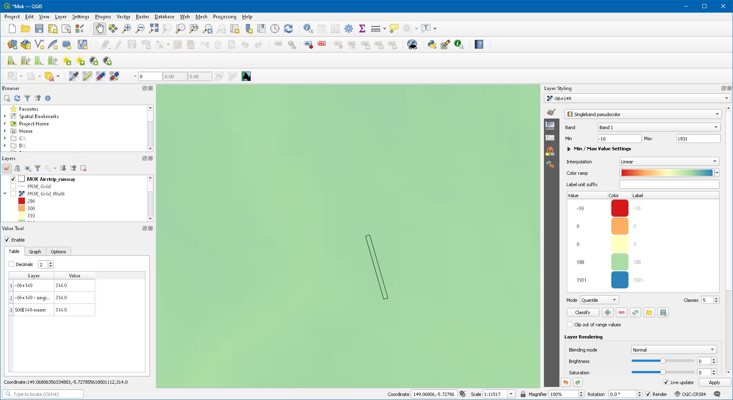

Google Earth

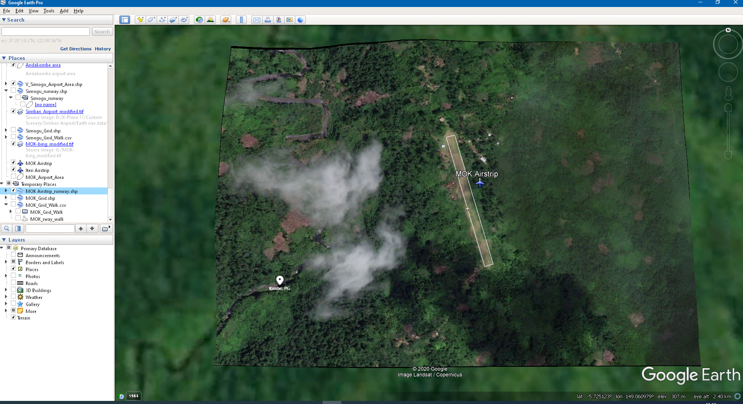

From here, you can ‘fly’ around in Google Earth and look at the terrain and how it lies relative to the runway. Bear in mind that obviously the Google Earth image is as ‘real as it gets’. Once you have seen the runway area and / or seen real footage from YouTube pilot / drone videos you can decide what area you want to edit (if any).

For this, I use the polygon tool in Google Earth to outline the area of interest. In this case it is rectangular but it doesn’t have to be but it needs to be a polygon.

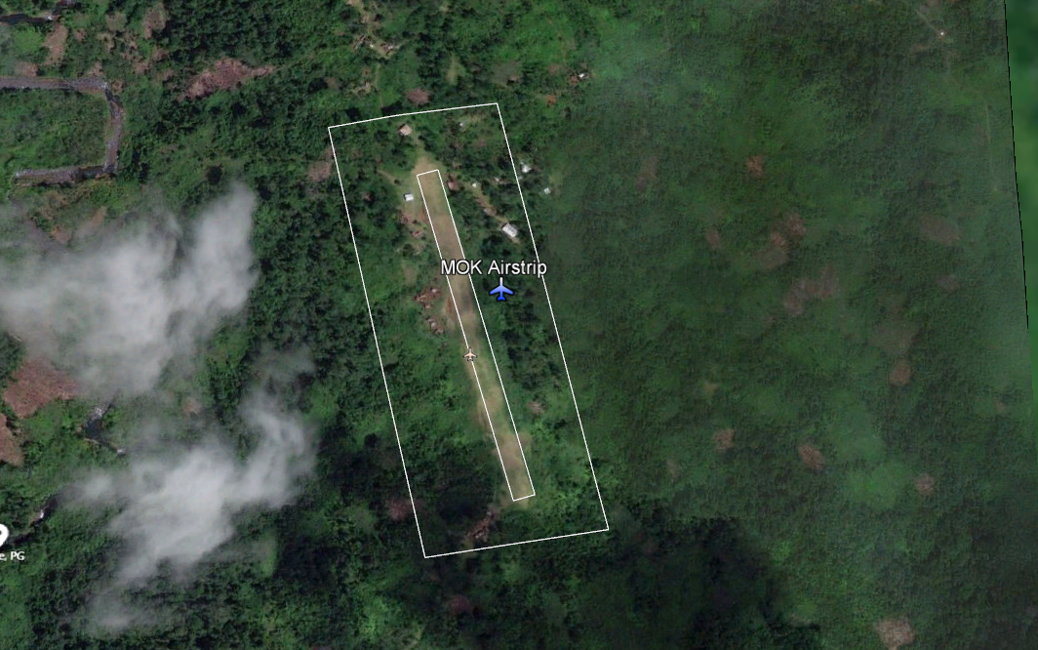

I save this as MOK_Airport_Area and export the .kml file defining it. You can export this as a shapefile using VFC.

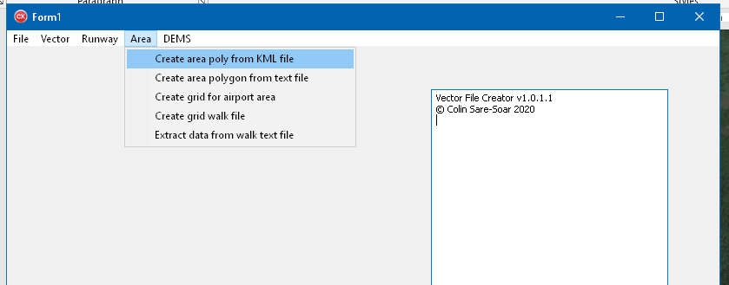

And then you can import the shapefile into QGis. There’s no need to import it into GE but you could.

So now you have the airport area showing and the runway, now you need the dem data.

There are several options here depending on what you want to do eventually. You can work with a new SRTM file from NASA but you are likely to find that the data is more-or-less the same as X-Plane’s default anyway. However, if you plan to generate a new dsf using Meshtool, you will need to get it. This can be directly imported into QGis so you can see how the terrain is mapped in respect to your airport and runway.There are 2 versions of the SRTM files on NASA, regular and sub-sampled. They are identical sizes 1201 x 1201 points but do differ slightly in places. I find it useful for comparaison with GE elevations but that’s about all unless you are generating a new mesh. I did this a few times and you can feed the airport area shapefile in and declare it as airport.terrain and Meshtool will not make any awkward triangles inside your area. It will not flatten anything, just re-write the mesh around your area. This is great except that it might upset the mesh under existing airports in the same tile so I gave up on this idea although it worked very well for my airport. This is where muxp comes in as it will only transform the area you define and not the whole tile.

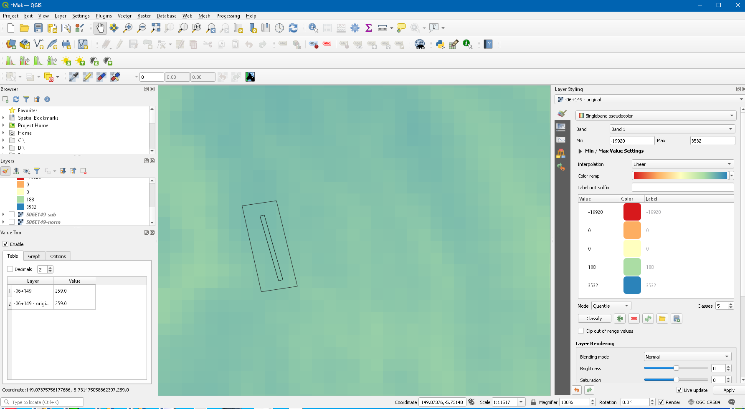

You can also import .kml files straight into QGis but not into Meshtool, that requires shapefiles.

In QGis, you can have multiple layers of dem data loaded at the same time for comparaison which is useful. You will be able to see why your new runway is unflyable. You can also run the basic area through muxp and then display the triangles in Google Earth. This will give you some hints about the area you need to edit. Please read the muxp manual for details.

If you find anomalies that you want to edit then you will have to decide how much needs doing. It is always worth trying muxp first to see how the runway looks after the edits that muxp does.

You may find that in less-populated mountainous areas that the basic dem data isn’t all that accurate and although the runway may be usable, the surrounding terrain doesn’t blend in very well. This has been my experience in PNG especially. In this case you will need to edit the underlying dem data.

1. More advanced topics

At this point you probably have the runway and airport area saved as shapefiles and you have looked at them in GE and/or another GIS. Now you need to define the area to edit. This is where examining the runway and surrounding terrain in GE comes in. Using the data already extracted you can create a grid covering the airport area with the gridlines aligned with the pixel edges in the dem data set. Each screen square will be approximately a 30m ground square. You perform this action using the Area | Create grid for airport area. The grid is calculated using the extremities of your defined area.

This file will be saved as XXX_grid. Shp shapefile set. This is a polyline file, not a polygon file but it can easily be displayed in GE / QGis

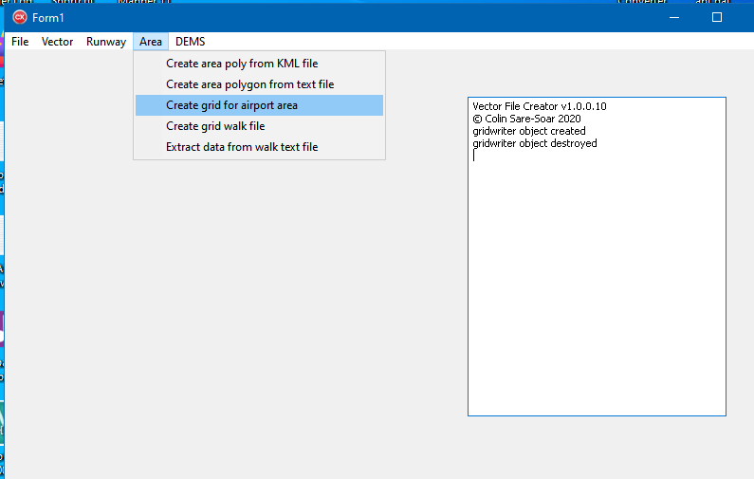

Grid file in QGis

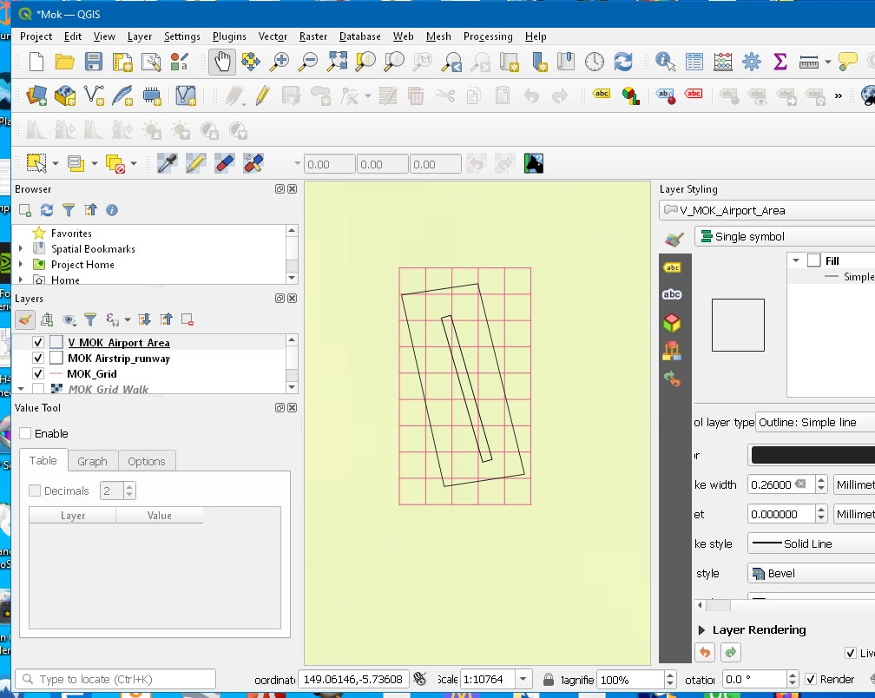

I read a lot of sites showing how to get dem data for a particular area and they all involved creating a ‘walk’ through the area, simulating a GPS track. These sites show using a mouse in GE to create a polyline and these guys scribble like a child all over their area of interest, creating hundreds and hundreds of points in GPS or CSV format. This file of coordinates is then fed into one of various sites which will give you the data for these points. This is good but rather excessive given that we only want samples for 30m squares, so I create a ‘walk’ file programatically linking all the centres of the grid squares. Once you have this file you can get the data online from (say) GPSVisualizer or a similar site. However, this will just get you the latest SRTM data and it probably won’t differ too much from X-Plane. An alternative is to load the grid and the walk files into GE and take the elevations from the screen. There won’t be that many; most of my runways are 5 x 9 or 11 x 6 (pixels) or something in that order. I find the easiest way is to have the coordinates in a spreadsheet and put the elevations in an extra column. Save this as a CSV for later use. Ignore Microsoft’s csv warning as it isn’t relevant.

You can also sign up to Google developer portal and get the data direct from Google but it isn’t that straightforward to do and probably not worth it just for the odd airport now and then.

The walk file will be named xxx_grid_walk.csv and can be imported into QGis or GE. It will show as a series of small circles in the centres of the grid squares.

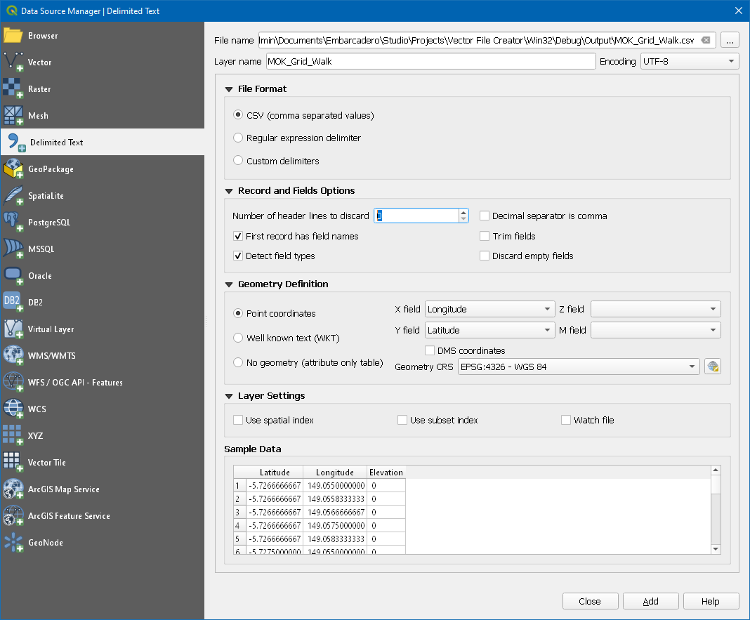

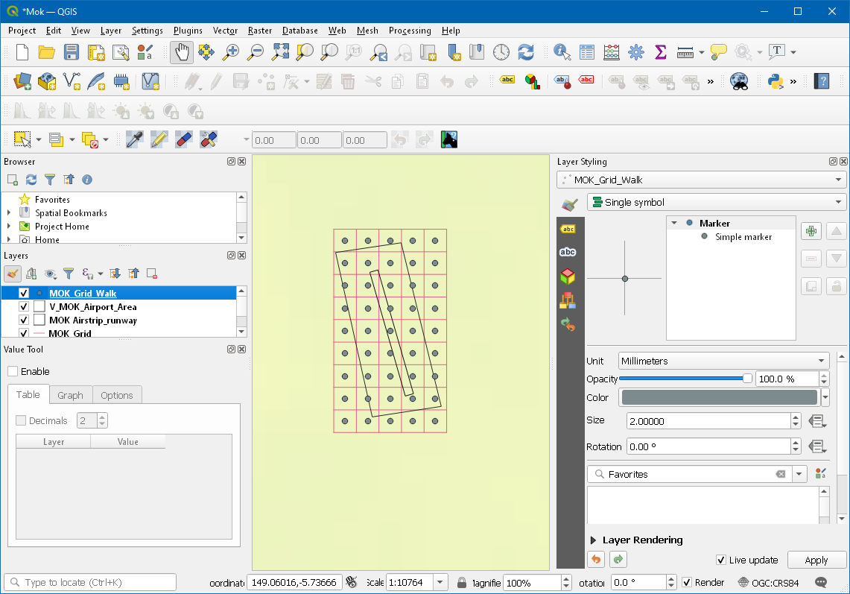

In Google Earth:

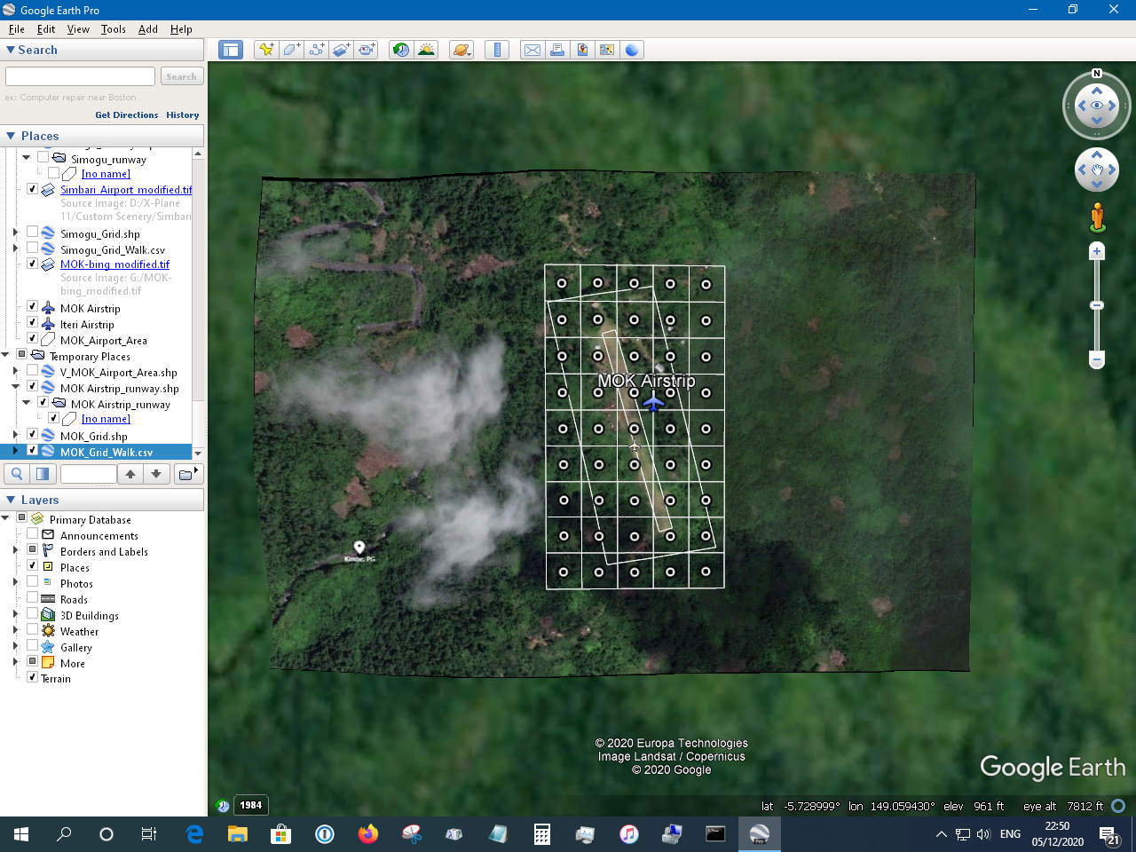

Once you have this data, you can create a mini-dem file in BIL format and import that into QGis. Using a plugin called value tool you can compare the dem squares from your different sources. For this, you need to load it into a GIS.

Here is the data loaded into QGis and you can see the Value Tool plugin bottom right showing the differences in all the different DEM layers. There should not be huge differences but just a few metres in a pixel that falls under the runway can make a big difference.

All this is quite interesting but you need to decide whether or not to edit X-Plane’s dem data. Check the values for the whole grid against GE’s values to see the differences.

This tool was written with a view to it being sort of a pre-processor for Muxp, in that if you create an area using cut_polygon and give a value of -37268 Muxp will use the existing dem values stored in the dsf for calculating the new triangles. The more accurate the underlying data is, the better the results will be from Muxp.

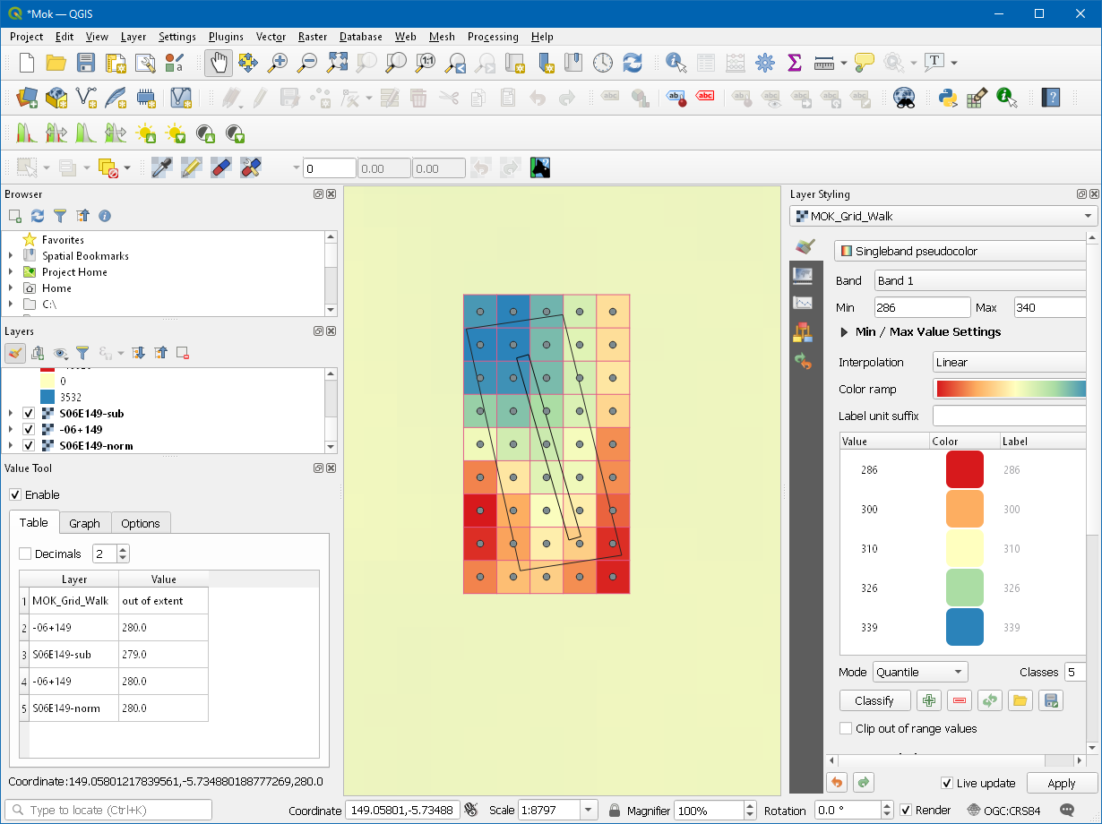

You should also export the dem data from the dsf file so that can be loaded into QGis as well. I typically will have at least 3 layers open, the ‘walk’ dem file, the X-Plane dem and the SRTM HGT file. Also I will display the grid and the ‘walk’ centres. Then you have to decide if you want to edit the X-Plane dem.

You can edit any of the dems using the Serval plugin and save them but somehow they need to be imported into X-Plane. If you plan on using Meshtool then edit the SRTM data and then use that in Meshtool. More of which later.

Otherwise, you need to patch the X-Plane dem with the walk dem file, using the DEMS | Patch DSF DEM. This function will patch the dsf directly and then it can be copied to your custom scenery folder and X-Plane will use it. Muxp will also use this edited file if you tell it to and you should get beter results.

Notes about DEM data.

SRTM data is a square block 1201 x 1201 data points with no headers or extra files. Software simply reads the data and makes assumptions based on the filename and extension. You can get 1 arcsec data which is 3601 x 3601 but X-Plane currently cannot use this. The data is stored in signed short integers in little-endian format. This doesn’t matter as VFC and all GIS programs know this automatically.

SRTM is Shuttle Radar Topography Mission and comes from NASA but other sites do mirror the data.

BIL format.

This is an ESRI format and very widely used. It can be read by just about all GISs. There are 3 files in the set and the GIS may create a 4th index file. The data is in BIL (Binary Interleaved) format and is the same as SRTM (normally) consisting of a 1201 x 1201 block. The header file xxx.hdr defines various properties such as the upper left corner coordinate, block size, numeric format and endiness. VFC uses the basic big-endian, short int format the same as SRTM, except big endian. The user does not have to worry about this. There is also a xxx.prj file which is the projection data but given that X-Plane uses WGS-84 and geographic projection there are no issues with this file. It does not require any editing but needs to be there in every set created.

BT format.

This is Binary Terrain v 1.3 created for The Visual Terrain Project which has a very nice flying function to visualize the mesh data. Landserf will also load .bt files as will QGis. It is a singular file and so VFC also creates a .bt file when extracting dem data. This isn’t required but there in case it is needed.

7Zip.

X-Plane stores the dsf files as 7zip archives. I cannot find a way to extract these files in VFC therefore the user will have to do it manually. When a dsf file is selected it will be copied to the Input folder and renamed 7zxxxyyyy.dsf. When extracted using 7zip it will be saved as it’s original filename.

1. Extracting DEM data from DSF files.

To export the X-Plane DEM data into a usable file, use the DEMS | Extract DSF DEM. This function will read the dsf file and extract just the dem data and create a BIL file, and a .BT file as previously explained. The dsf file will remain intact and unchanged. It will be saved as e.g. -06+149.BIL and can be loaded into QGis the same as any other layer.

1. Patching DEM files.

There are currectly 3 options under the DEMS menu for patching 3 different file types. As mentioned several times above, if you intend using Meshtool then patch the HGT file but this probably is not necessary as Meshtool re-calculates the terrain for the whole tile. It won’t do any harm so try it out using the shapefiles defined previously.

You can patch a BIL file but this was really for testing more than anything else. You can’t (yet) do much else with this function.

The intention is to patch the dsf file directly. The extracted data is only to view for comparison purposes. Once you have the elevation data (from somewhere) saved as a CSV file in the following format:

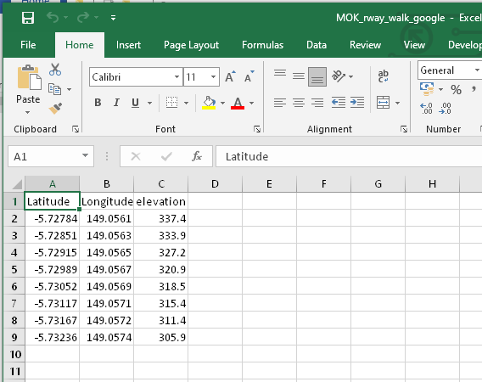

VFC will import this and patch the dsf directly. VFC does not re-calculate the hash for the dsf file so the hash will be wrong but X-Plane doesn’t care.

You can store / copy the modified dsf file into the custom scenery folder where it should be read on the next start and where it can be modified with scenery using WED once you are happy with the terrain. If you need further processing, e.g. the runway profile still has bumps (caused by the triangulation, rather than the actual terrain) then you will need to process the file with Muxp to re-triangulate and make a nice splined runway. Performing the above steps first should make the Muxp terrain blend in better, at least that is what I have found.

1. Runway profile.

In the same way that you create a walk file (manually) you can create a runway profile in GE. Simply create the file drawing a line down the centre of the runway clicking points at intervals. It is not necessary for these to be regular as the coordinates and elevation are saved. You can view this in a new window at the bottom of the screenby right-clicking the entry on the side bar and chosing show elevation profile.

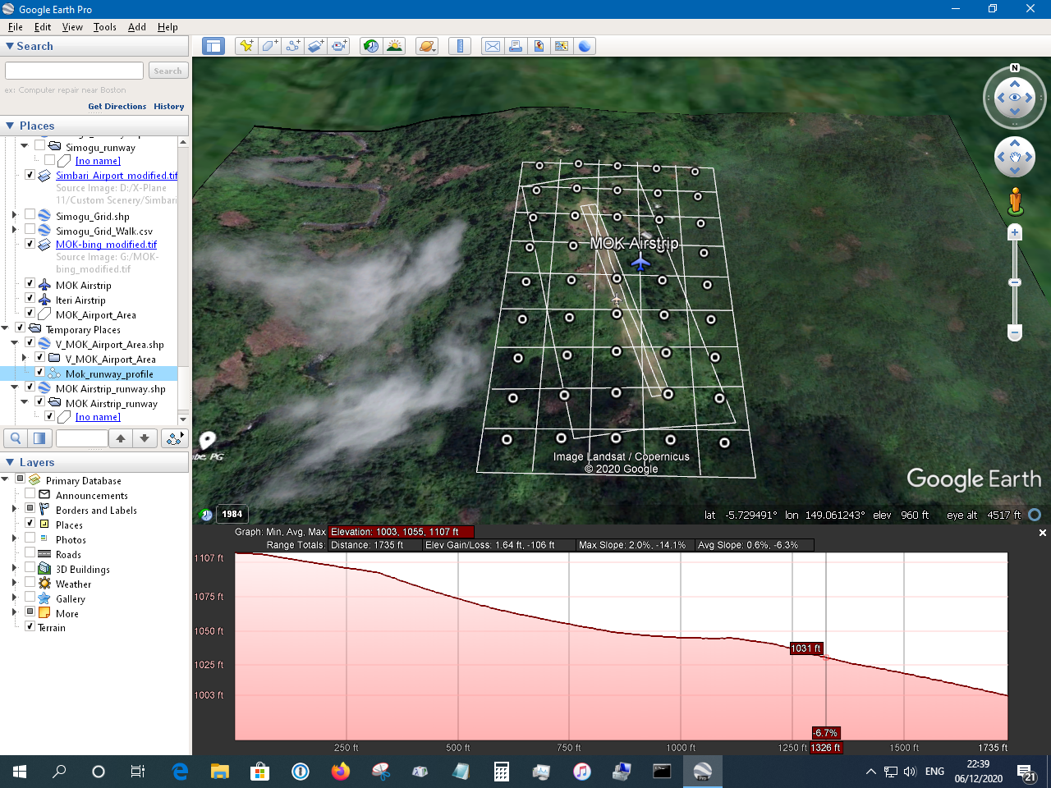

This can be saved as a KML file and can be exported as a csv file from VFC to obtain the best elevations and / or modify them .

VFC can create a muxp input file along similar lines to the auto-muxp function, using the defined area and runway profile. It also requires the runway vector file for some details.

There is a Win32 binary available, together with the Embarcadero run-time libraries. As mentioned, VFC was written using Embacadero C++ Builder and will not compile under MSVC or probably any other C++ system due to the visual components.

1.